

**KRISHNA ENGINEERING COLLEGE**

**Data Structure Lab**

**KCS – 301**

SUBMITTED BY:-

**SUNIL MAURYA**

**1901610100211**

SUBMITTED TO:-

**Ms. RASHMI SHARMA**

|  |  |  |  |  |
| --- | --- | --- | --- | --- |
| |  | | --- | | **Krishna Engineering College**  **Department of Computer Science and Engineering** | | | |  |
| **Name: SUNIL MAURYA**  **Roll No.:1901610100211** | | |  |
|  |
| **Year/Semester:- 2nd/III** | | **Session:- 2020-21** |  |
| **Subject Name:- Data Structures** | | **Subject Code:- KCS-301** |  |
| **Faculty :-** | **Ms. RASHMI SHARMA** | **Section/ Group:**  **B/2** |  |
|  |  |  |  |
| **S.No** | **Program Name** | **Scheduled Date** | **Sign** |
|
| 1 | Implementation of Linear search |  |  |
| 2 | Implementation of Binary search (using recursion and without using recursion) |  |  |
| 3 | Implementation of Selection sort |  |  |
| 4 | Implementation of Insertion sort |  |  |
| 5 | WAP in C to perform traversal of an array |  |  |
|  |  |  |  |
|  |  |  |  |

**Q1. WAP to implement Linear Search in C.**

|  |
| --- |
| #include <stdio.h> #define MAX 20  int linear(int array[], int n, int key);  int main() {  int i, n = MAX - 1, key, index;  int array[MAX];   printf(" ----- Linear Search -----\n\n");  printf("[*] Enter Size of Array : ");  scanf("%d", &n);   printf("\n[*] Enter Elements of Array : ");  for (i = 0; i < n; i++) {  scanf("%d", &array[i]);  }  printf("\n[*] Enter element to search : ");  scanf("%d", &key);   index = linear(array, n, key);   if (index != -1) {  printf("\n[*] Found %d at pos %d", key, index + 1);  } else {  printf("\n[!] Given Array Does nOt Contain Element %d ", key);  }   printf("\n\n-------------------------\n\n");  return 0; }  int linear(int array[], int n, int key) {  int i, idx = -1;  for (i = 0; i < n; i++) {  if (array[i] == key) {  idx = i;  break;  }  }  return idx;  } |

Output →

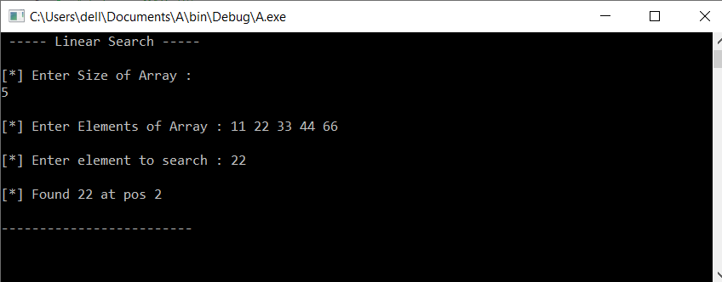

Q2.

**(A). WAP to implement BINARY Search (Without Recursion) in C.**

|  |
| --- |
| #include <stdio.h> #define MAX 20  int binary(int array[], int n, int key);  int main() {  int i, n = MAX - 1, key, index;  int array[MAX];   printf(" ---- Binary Search ----\n\n");  printf("[*] Enter Size of Array : ");   scanf("%d", &n);   printf("\n[*] Enter Elements of Array : ");  for (i = 0; i < n; i++) {  scanf("%d", &array[i]);  }  printf("\n[*] Enter element to search : ");  scanf("%d", &key);   index = binary(array, n, key);   if (index != -1) {  printf("\n[*] Found %d at pos %d", key, index + 1);  } else {  printf("\n[!] Given Array Doesnt Contain Element %d ", key);  }   printf("\n\n-------------------------\n\n");  return 0; }  int binary(int array[], int n, int key) {  int idx, low, high, mid;   idx = -1;  low = 0;  high = n - 1;   while (low <= high) {  mid = low + (high - low) / 2; *// prevents overflow*  if (array[mid] == key) {  idx = mid;  break;  } else if (array[mid] < key) {  low = mid + 1;  } else { *// array[mid] > key*  high = mid - 1;  }  }  return idx; }  Output → |

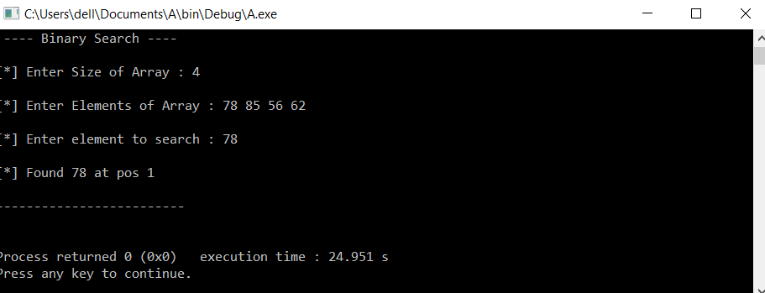

Q2

**(B). WAP to implement BINARY Search (Using Recursion) in C.**

|  |
| --- |
| #include <stdio.h> #define MAX 20  int binary(int array[], int low, int high, int key);  int main() {  int i, n = MAX - 1, key, index, low, high;  int array[MAX];    printf(" ----- Recursive Binary Search -----\n\n");  printf(" [*] Enter Size of Array : ");   scanf("%d", &n);   printf("\n [*] Enter Elements of Array : ");  for (i = 0; i < n; i++) {  scanf("%d", &array[i]);  }  printf("\n [*] Enter element to search : ");  scanf("%d", &key);   low = 0;  high = n - 1;   index = binary(array, low, high, key);   if (index != -1) {  printf("\n [*] Found %d at pos %d", key, index + 1);  } else {  printf("\n [!] Given Array Doesnt Contain Element %d ", key);  }   printf("\n\n -----------------------------------\n\n");  return 0; }  int binary(int array[], int low, int high, int key) {  int mid = low + (high - low) / 2; *// prevents overflow*   if (low > high) {  return -1;  } else if (array[mid] == key) {  return mid;  } else if (array[mid] < key) {  return binary(array, mid + 1, high, key);  } else { *// array[mid] > key*  return binary(array, low, mid - 1, key);  } } |

Output →

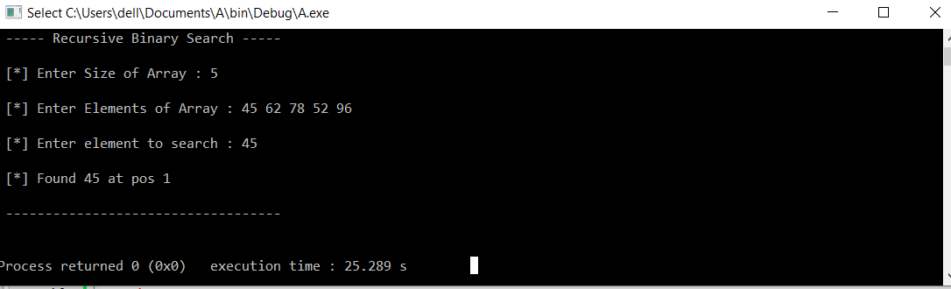

Q3**. WAP to implement Selection Sorting in C.**

|  |
| --- |
| #include <stdio.h> #define MAX 10  void selection_sort(int *array, int n);  int main() {  int i, n;  int array[MAX];    printf("- Selection Sort -\n\n");  printf("[*] Enter Size of Array : ");   scanf("%d", &n);   printf("\n[*] Enter Elements of Array : ");  for (i = 0; i < n; i++) {  scanf("%d", &array[i]);  }   selection_sort(array, n);   printf("\n[*] Sorted Array : ");   for (i = 0; i < n; i++) {  printf("%d ", array[i]);  }  printf("\n\n ----\n\n");  return 0; }  void selection_sort(int *array, int n) {  int idx, temp;  for (int i = 0; i < n - 1; i++) {  for (int j = i; j < n; j++) {  if (array[i] > array[j]) idx = j;  }  temp = array[i];  array[i] = array[idx];  array[idx] = temp;  } } |

Output →

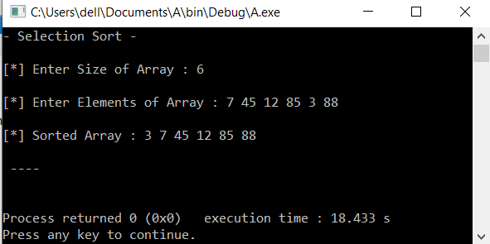

Q4. **WAP to implement Insertion Sorting in C.**

#include <stdio.h>

#define MAX 10

void insertion_sort(int *array, int n);

int main() {

printf("\n -----------------------");

printf("\n | SUNIL MAURYA |");

printf("\n | CSE 2B |");

printf("\n | Roll NO 1901610100211 |");

printf("\n ----------------------- ");

printf("\n\n");

int i, n;

int array[MAX];

printf(" ----- Insertion Sort -----\n\n");

printf("[*] Enter Size of Array : ");

scanf("%d", &n);

printf("\n[*] Enter Elements of Array : ");

for (i = 0; i < n; i++) {

scanf("%d", &array[i]);

}

insertion_sort(array, n);

printf("\n[*] Sorted Array : ");

for (i = 0; i < n; i++) {

printf("%d ", array[i]);

}

return 0;

}

void insertion_sort(int *array, int n) {

int temp_idx, temp;

for (int i = 1; i < n; i++) {

temp_idx = i - 1;

temp = array[i];

while (temp_idx >= 0 && array[temp_idx] > temp) {

array[temp_idx + 1] = array[temp_idx];

temp_idx--;

}

array[temp_idx + 1] = temp;

}

}

Output →

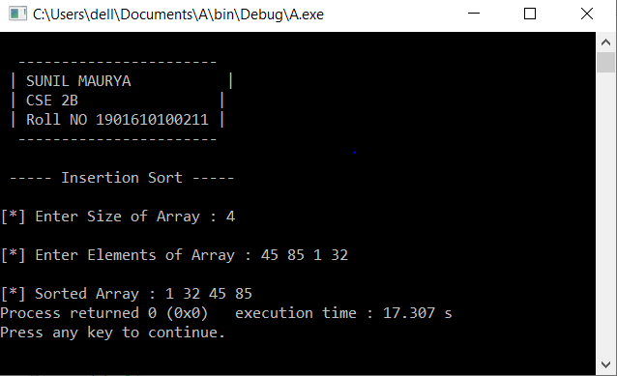

Q5**. WAP in C to perform traversal of an array.**

#include<stdio.h>

#include<conio.h>

Void main()

{

Int n, i ,a[i];

Printf(“enter the limit of array\n”);

Scanf(“%d”,&n);

Printf(“enter an array\n”);

for(int i=0;i<n;i++){

scanf(“%d”,&a[i]);

}

Printf(“ your array \n”);

for(int i=0;i<n;i++){

printf(“%d”,&a[i]);

}

getch();

}

Output →

